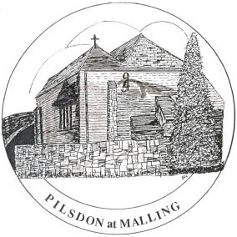The Pilsdon at Malling Community

**Resident Volunteer Vacancies**

Are you planning a gap year or taking time out to do something different? If so, how about coming to a working and caring community with a real purpose? We are looking for new volunteers to join our friendly team – for any period from one to six months. We are an ecumenical Christian charity that takes in, walks with and encourages people recovering from crises in their lives. And we live in an old monastery on the outskirts of a beautiful Kent village, looking after a six-acre smallholding.

Community Members, led by the Guardian, make up the core team who together take responsibility for maintaining the Christian ethos and managing the property. Our resident volunteers live alongside us and share in all day-to-day activities. Everyone mucks in with whatever needs doing around the place and in taking care of our guests, visitors and occasional wayfarers.

You will need good practical and pastoral skills. Our work includes cooking, cleaning, gardening, looking after livestock and helping in the office. If you are reasonably fit and enthusiastic about serving others, we would love to hear from you. In addition to a strong Christian faith, you will be resilient, trustworthy, kind and compassionate.

For further information, please contact the Revd James McKeran at [guardian@pilsdonatmalling.org.uk](mailto:guardian@pilsdonatmalling.org.uk) or phone for a chat on 01732 870279.

